Requirement
- Please write a personal statement for application to MSc Economics at Hong Kong University of Science and Technology and MSc Economics at Chinese University of Hong Kong. The program websites are for your references.
HKUST: https://mscecon.hkust.edu.hk/
CUHK: https://admission.econ.cuhk.edu.hk/pg/master-economics/
- The PS should be explaining why you are interested in studying this Programme, why you are suitable for it and the value of the Master Programme to your future career.
- The PS should have two different endings customized for HKUST and CUHK according to their program features.
- Please write the PS using the background provided in the resume. However, you can fabricate some details to make the PS more interesting and convincing, as long as they do not contradict the resume.
- The applicant is born and raised in China and came to Canada for university in 2018. The career goal after graduation of MSc Economics is to work at a big consulting firm.

RESUME
EDUCATION
Dalhousie University, Halifax, NS, Canada, 09/2018-04/2022
Bachelor of Science in Economics GPA: 3.85/4.3
GRE 333, Verbal 163 (92%) Quantitative 170 (96%)
Awards: Dean’s list 2021, 2022 W. Andrew MacKay Alumni Scholarship 2021
Main Courses: Intermediate Microeconomics, Intermediate Macroeconomics, Linear Optimization, Linear Algebra, Mathematical Modelling, Intro Data Mining with R, Intro to Econometrics, Microeconomic Theory, Macroeconomic Theory, Intermediate Statistics

WORK EXPERIENCES
Deloitte Consulting, Toronto, Canada 05/2022-Present
Data Analyst, Data Science Team
- Design and implement end-to-end data-oriented solutions to solve business challenges for large Canadian energy corporations
- Lead weekly technical meeting of five, checking on the quality and accuracy of data,
- Process, design and present the data to make better decision. troubleshoot data issues.
CITIC Securities, Henan, China 06/2021-08/2021
Summer Intern, Investment Banking
- Prepared IPO prospectus for a 300-million-RMB company
- Conducted market research, collected and sorted financial information for client companies
Scotia Bank, Halifax, NS Canada 05/2020-08/2020
Data Analyst Intern
- Analyzed financial information from Bloomberg, counterparty risk profile, and investment strategies
- Prepared and maintained executive summary and risk summary reports for the GCM Banking portfolio

RESEARCH PROJECTS
Impacts of climate change on residential demand for electricity in Nova Scotia
Summarization: The report produces projections of future electricity demand in the province under different climate changes scenarios, and we suggest significant investment in power generating capacity to meet the demand by 2090.

ADDITIONAL
VP of Chinese New Year Activities, Halifax, NS, Canada Jan 2019-Feb 2020
- Organized Chinese new year celebration activities, secured sponsorship outside campus
Volunteer Leader, Freshman Orientation Team, Dalhousie University Jul 2019-Feb 2020
- Received accepted students at registrar and guided them during campus tour, helped with admission arrangement
Programming skills: Python, R
Hobbies: Tai Chi, Chinese Chess, Skiing

-------------------------------Transcript----------------------------------------
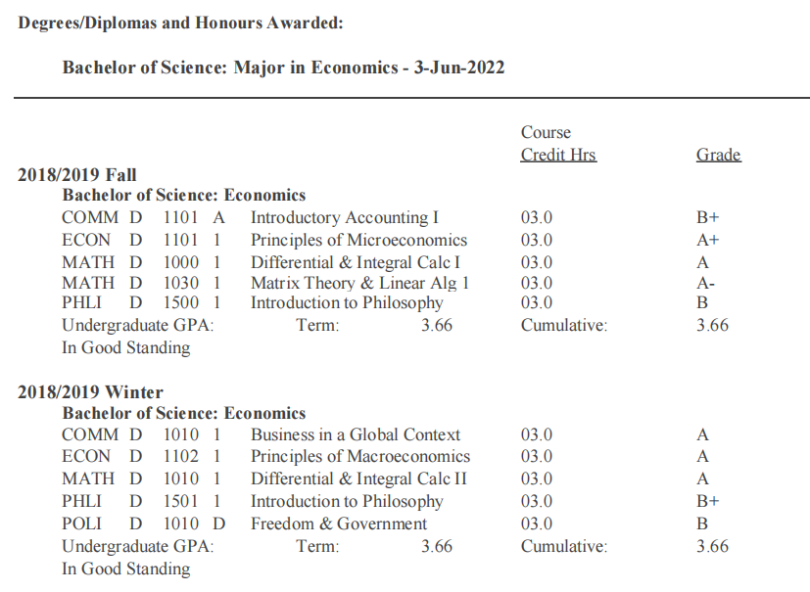
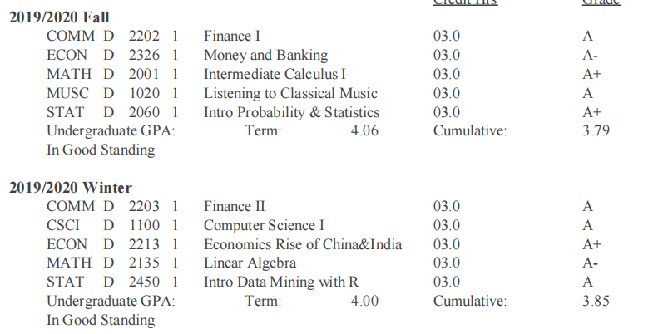
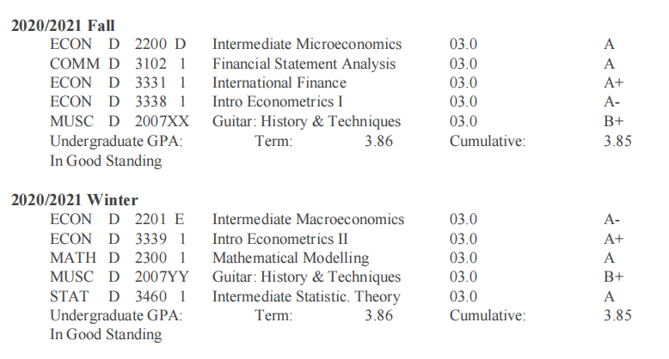
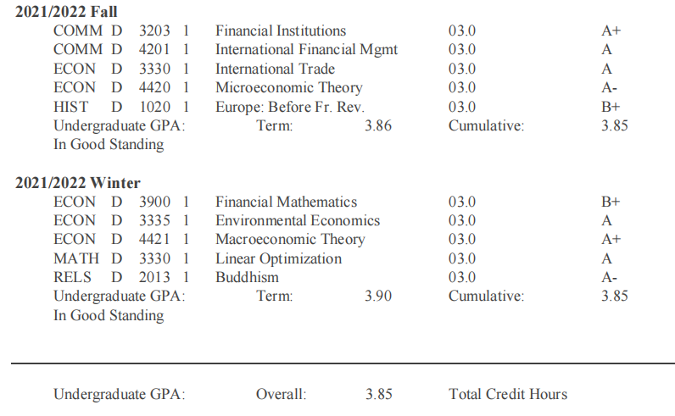

Research: Impacts of climate change on residential demand for electricity in Nova Scotia
Abstract
The relationship between climate change and energy is often misperceived as being
unidirectional. That is, production and consumption of energy sources, including
electricity, emit greenhouse gases (GHG) that contributes to global warming. While
correct this view ignores the impacts of rising temperature on energy consumption. The
feedback effects of climate changes are mainly due to changes in heating/cooling
requirement and often vary geographically. So far, there has not been any studies
investigating such relationship in the province of Nova Scotia. This report seeks to
fill this gap and looks at the impacts of climate changes on the future of households’
demand for electricity in the province. In doing so, we come up with projections of future
electricity demand in the province under different climate changes scenarios. Under our
most aggressive projections, significant investment in power generating capacity will be
needed to meet a demand of 11Mwh by 2095

