In this assignment, you will use SAP Analytics Cloud to analyze museli sales data from various teams that participated in an ERPsim game. This assignment is due on October 5 before midnight.

Sign up for a trial SAP Analytics Cloud account at https://www.sapanalytics.cloud/.

Import the attached ERPSIM_E7_1 Excel file into SAP Analytics Cloud.

Perform data visualization analysis to answer the ten questions in the attached Assignment 2 instructions.

Export your story of 10 slides as a PDF file with your data visualization results and answerData visualization using SAP ANALYTICS CLOUD

Nitin Kalé, University of Southern California

Nancy Jones, San Diego State University

Objective
Use data visualization to analyze ERP simulation game data using SAP Analytics Cloud.

Activities
- Import and prepare data
- Perform data cleansing and harmonization
- Create data visualizations
- Share results as a slide show / storyboard

Software Prerequisites
- SAP Analytics Cloud

UCC Products Required
- None

Data Required
- ERPSIM dataset is available in ERPSIM_E7_1.xlsx

Scenario
Many courses at SAP University Alliances member schools use ERP Simulation Game (ERPSIM) to introduce students to the role of integrated business processes using a business simulation game. This game simulates a commodity market wherein teams have to plan, procure, produce and sell products in a competitive environment. The goal is to strategize and run their company for profit maximization. The game is played in the SAP ERP system while an external simulator simulates the dynamic market and all the variables that influence the game. This exercise can be used during or at the end of the game to analyze game data. To learn more about ERPSIM, go to erpsim.hec.ca

Data Visualization
The human visual system has evolved to be particularly good at recognizing patterns. Data visualization has become a standard analytical tool which capitalizes on the ability of humans to recognize patterns within massive quantities of multi-dimensional data generated by business information systems. Many scientific studies have led to the creation of visualization models that utilize human perception and cognition.
When the number of dimensions is small, we can use standard graphing techniques for visualization e.g. bar charts, line charts, histograms, pie charts and scatter plots. In this exercise, you will use basic visualization techniques to analyze ERPSim data.

What is ERPSIM?
The ERPSim game is played by teams over several rounds (up to 12 rounds of 20 virtual days each). The teams sell up to 12 products that the market consumes. The products are all muesli cereal in various flavors and box sizes. The teams must forecast demand, run MRP, procure, produce, price and market their products for sale.
Figure 1 shows the entire cash-to-cash cycle in the game. The transactions in bold are decision points that teams must make and execute. They are considered strategic in nature. The transactions that are gray are considered operational in nature. They are automated by the simulator. Additionally, teams can run analytical reports at various points in the game to monitor and strategize.
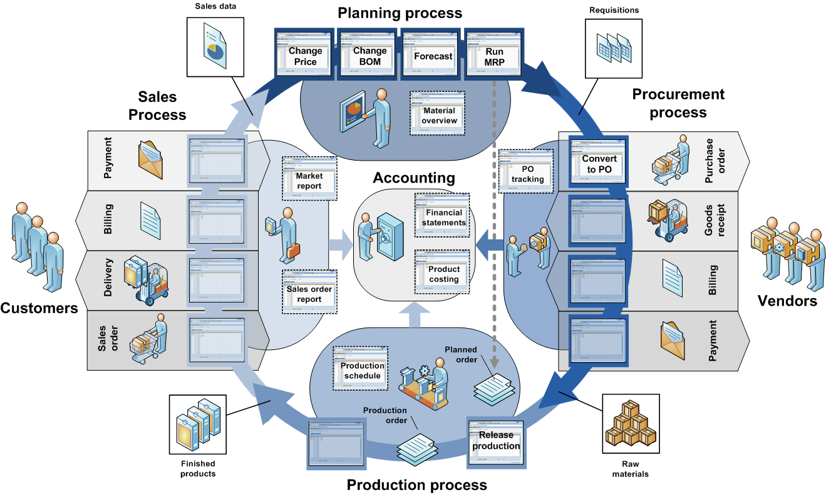
Figure 1: Cash-to-cash cycle
Data from an actual game have been extracted from SAP ERP and stored in an Access database. Then queries have been written to report important findings. The results have been exported to Excel.

Data Visualization for ERPSIM
You will now use SAP Analytics Cloud to acquire ERPSim game data, and to visualize and discover any interesting trends.
- Create a trial account for SAP Analytics Cloud at https://www.sapanalytics.cloud/.
- Import the ERPSim data in the Excel file ERPSIM_E7_1. You should have 6,558 rows of data.
Choosing measures and dimensions
What is a measure? A measure is a field on which calculations can be made. These are fields of business interest for analytics. e.g. revenue, profit, quantity sold. The calculations can sum, min, max, average, count etc. Measures are also called key figures or facts.
What is a dimension? A dimension is reference information about a measure. It provides context for the measures; such as, customer, time, product. Revenue by customer is an example of how you would report a measure by a dimension.
  - Since the values in Round, Day, Distribution Channel, and SalesOrder are numeric, SAP Analytics Cloud has incorrectly identified them as measures.
  - Hover your mouse over Round, click on the “…” at the end and select “Change to Dimension. Repeat these steps for Day, Distribution Channel, and SalesOrder.
- You are now ready to manipulate and visualize these data.
  - From the hamburger menu on the top left, select Create->Story->Report.
  - Several charting options are available for visualization – bars, lines, pies, geographic, scatter/bubble, maps, radar, tag cloud etc.
  - Using the appropriate charting technique, answer the following questions.
  - You will be creating a storyboard of all your visualizations so be sure to save each one. Remember, you can do that by clicking on the plus sign at the bottom of the visualize page.
Question 1: Which team had the highest revenue? What was the revenue?

Question 2: What product had the highest revenue? What was the revenue?

Question 3: Display the trend of revenue over rounds for each team.

Question 4: What is the market share of each team by product?
Hint: Use a stacked bar chart or a trellised pie chart
Question 5: Are there any products that don’t sell in specific distribution channels?
Hint: Use a heat map.
Question 6: What were the highest prices paid for various products per team? Which team sold the most expensive Muesli?
Question 7: Which team sold the most quantity of muesli? For that team, what was the most sold product?
Hint: Use a Bar/Column Chart. Measure – Quantity, Dimension – Team. Right click on team with highest quantity to filter then add Dimension: Product.
Question 8: What three products have high price and high revenue? _______
Hint: Use a Bubble chart. Measures: Y-axis: Quantity. X-axis: Price. Dimension: Product, Bubble Size: Revenue.
Question 9: Show the days on which individual teams did not have any revenue. What team made the highest revenue on a single day (which round)?
Hint: Use a Heat Map. X-axis: Round, Y-axis: Day, Color: Revenue. Then click on “…” on the top right corner, select Add->Trellis: Team. Then click on “…” on top right corner and select Rank-> Top 5.
Question 10: What product on what day and round brought the highest revenue (for which team)?
Hint: Use a Stacked Bar/Column. Measure: Revenue, Dimensions: Round, Day, Color: Team, Product. Then click on “…” on the top right corner, select Rank-> Top 5.

EXPORTING YOUR REPORT TO PRD
Click on the dropdown list next to Save and select Export.

Grading Parameters
- Message is clearly presented.
  - The answer to the question is clearly shown on the visualization and
  - appropriate visualization is chosen.
- Visualization is labeled and titled (see the example above).
- Various visualizations are used, not just one type for all questions.
- Parameters of the assignment have been met.

http://en.wikipedia.org/wiki/Muesli
Léger, P.-M., Robert, J., Babin, G., Pellerin, R. and Wagner, B. (2007), ERPsim, ERPsim Lab, HEC Montréal, Montréal, Qc.

