Topic: Read the ethics case "Deciding Who Receives the Swine Flu Vaccine" at the end of Chapter 3 of your text and respond to one of the following questions:
Question 1: From a utilitarian point of view, who do you think should be in the priority group? Explain your answer.
Direction: Class, Answer question in relations to the chapter passage below. Absolutely no plagiarism and use credible sources! Please cite textbook as a source. Class, use APA 7 edition format. If you do not use this format, you will lose points!
Textbook: Brooks, L. J., & Dunn, P. (2021). Business & professional ethics for directors, executives, & accountants (9th ed.). Cengage.

Chapter 3: Defining of Utilitarianism

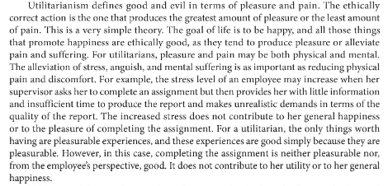

Chapter 3 Case
