IT 140 Design Document

Jasmine Bierschbach

Storyboard (Description and Map)
Upon entering the ruins of this ancient castle, you realize something doesn’t seem quite right. There’s a presence in the air, the magic remnants touching everything the Grand Mage has used. Little do you know, this place won’t be your sanctuary for long unless you get rid of the Grand Mage lurking on the second floor. In order to defeat the Grand Mage, you must raid his trophy room for a long bow and arrows for long range protection, enter his study to get magical protection robes to protect from his spellcasting, head to the kitchens for a health potion to keep up in battle, the library holds an iron mace for close combat fighting, his bedroom should a shield for blocking, and the bathroom should have a poison to poison your mace and inflict more damage. You must locate and equip each item before facing the Grand Mage.
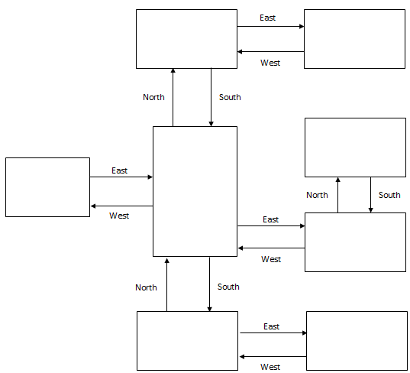
Attic:
Beware! Grand Mage is here!
Bathroom:
Weapon Poison
Receiving Hall:
Start Here
Bedroom:
Shield
Library:
Iron Mace
Kitchens:
Health potion
Study:
Magical protection robes
Trophy Room:
Long bow and arrows

Pseudocode or Flowchart for Code to “Move Between Rooms”
Commands: Go North, Go South, Go East, Go West

Pseudocode or Flowchart for Code to “Get an Item”
Add to inventory: get ‘item’

Pseudocode:
Collect 6 items to fight the Grand Mage and win the game.
Move commands: Go North, Go South, Go East, Go West
Add to Inventory: get 'item'

Player starts in the Receiving Hall
Inventory: []
---------------------------
Enter move command:
go North
You are in the Bathroom
Inventory: []
You see a weapon poison
-------------------------------
Enter move command:
Get weapon poison
Weapon poison retrieved!
You are in the Bathroom
Inventory: ['Weapon Poison']
---------------------------
Enter move command:
Go south
You are in the Receiving Hall
Inventory: ['Potion']
---------------------------
Enter move command:
Go west
You are in the Trophy Room
Inventory: ['Potion']
You see a longbow and arrows
----------------------------
Enter move command:
Get longbow and arrows
Longbow and arrows retrieved!
You are in the Trophy Room
Inventory: ['Potion’, ‘longbow and arrows’]
-----------------------------
Enter move command:
Go east
You are in the Receiving Hall
Inventory: ['Potion', ‘longbow and arrows]
-----------------------------
Enter move command:
Go south
You are in the Kitchens
Inventory: ['Potion', ‘longbow and arrows’]
You see a health potion
---------------------------------
Enter move command:
Get potion
Potion obtained!
You are in the Kitchens
Inventory: ['Potion', ‘Longbow and Arrows’, ‘Health Potion’]
--------------------------------
Enter move command:
Go East
You are in the Bedroom
Inventory: ['Potion', ‘Longbow and Arrows’, ‘Health Potion’]
You see a shield
-------------------------------
Enter move command:
Get shield
Shield obtained!
You are in the Bedroom
Inventory: ['Potion', ‘Longbow and Arrows’, ‘Health Potion’, ‘Shield’]
-----------------------------
Enter move command:
Go west
You are in the Kitchens
Inventory: ['Potion', ‘Longbow and Arrows’, ‘Health Potion’, ‘Shield’]
-----------------------------
Enter move command:
Go north
You are in the Receiving Hall
Inventory: ['Potion', ‘Longbow and Arrows’, ‘Health Potion’, ‘Shield’]
-----------------------------
Enter move command:
Go east
You are in the Library
Inventory: ['Potion', ‘Longbow and Arrows’, ‘Health Potion’, ‘Shield’]
You see an iron mace
------------------------------
Enter move command:
Get iron mace
Iron mace obtained!
You are in the Library
Inventory: ['Potion', ‘Longbow and Arrows’, ‘Health Potion’, ‘Shield’, ‘Iron Mace’]
------------------------------
Enter move command:
Go north
You are in the Study
Inventory: ['Potion', ‘Longbow and Arrows’, ‘Health Potion’, ‘Shield’, ‘Iron Mace’]
You see magical protection robes
----------------------------
Enter move command:
Get magical protection robes
Magical protection robes obtained!
You are in the Study
Inventory: ['Potion', ‘Longbow and Arrows’, ‘Health Potion’, ‘Shield’, ‘Iron Mace’, ‘Magical Protection Robes’]
-----------------------------
Enter move command:
Go south
You are in the Library
Inventory: ['Potion', ‘Longbow and Arrows’, ‘Health Potion’, ‘Shield’, ‘Iron Mace’, ‘Magical Protection Robes’]
-----------------------------
Enter move command:
Go west
You are in the Receiving Hall
Inventory: ['Potion', ‘Longbow and Arrows’, ‘Health Potion’, ‘Shield’, ‘Iron Mace’, ‘Magical Protection Robes’]
------------------------------
Enter move command:
Go north
You are in the Bathroom
Inventory: ['Potion', ‘Longbow and Arrows’, ‘Health Potion’, ‘Shield’, ‘Iron Mace’, ‘Magical Protection Robes’]
You see a weapon poison
-------------------------------
Enter move command:
Get weapon poison
Weapon poison obtained!
You are in the Bathroom
Inventory: ['Potion', ‘Longbow and Arrows’, ‘Health Potion’, ‘Shield’, ‘Iron Mace’, ‘Magical Protection Robes’, Weapon Poison]
------------------------------
Enter move command:
Go east
You are in the attic
Inventory: ['Potion', ‘Longbow and Arrows’, ‘Health Potion’, ‘Shield’, ‘Iron Mace’, ‘Magical Protection Robes’, Weapon Poison]
You see a Grand Mage
You have collected each item that is needed to defeat the Grand Mage
Congratulations! You have defeated the Grand Mage and claimed you sanctuary.
Thanks for playing! I hope you’ve had fun!

