A researcher is interested in cannabis use in groups of offenders. They find two scales that are commonly used to assess cannabis use, these are
1. The Cannabis use disorders identification test ‘CUDIT’, 8 items measured on a 0-4 scale
2. The Cannabis severity of dependence scale ‘SCDS’, 10 items measured on a 0-5 scale.
The first thing they do is explore the psychometric properties of each of these scales computing
- Split half reliability
- Cronbach’s alpha reliability
- Test retest reliability (compares a time one with time two; CSDS_TOTAL vs CSDS_TOTAL_2; CUDIT_TOTAL vs. CUDIT_TOTAL_2)

After reviewing the psychometric properties of the scale you are required to select the one that should be used to explore the extent to which different offender groups have different levels of cannabis consumption. For this analysis:
IV Offender type (between subjects): Car theft, Shop lifting, affray
DV: The cannabis use measure you select

The hypothesis is that there will be no significant differences across groups

The analysis using both the possible DVs have been given you must select the best one to report.

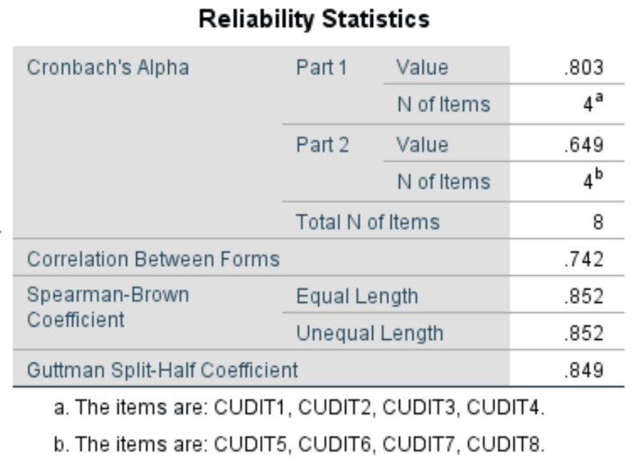
CUDIT
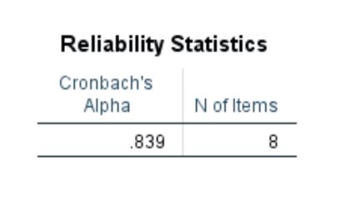

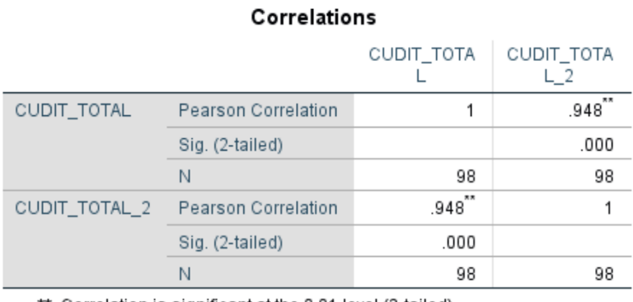

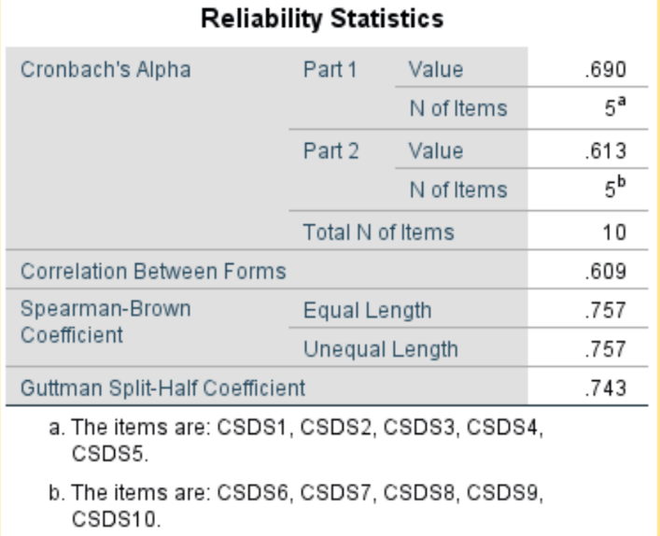
CSDS
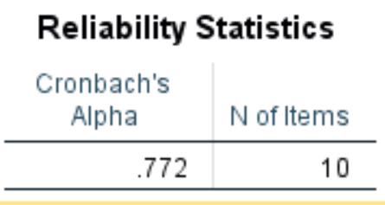

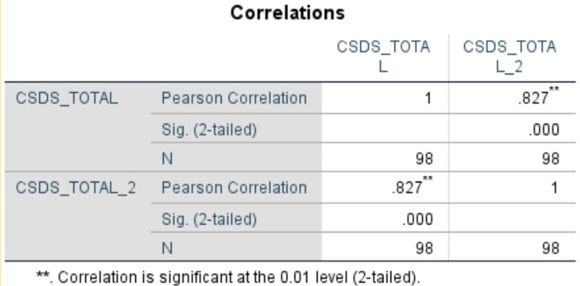

Offender type on CUDIT
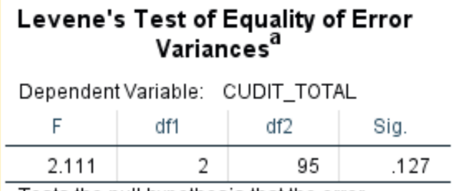
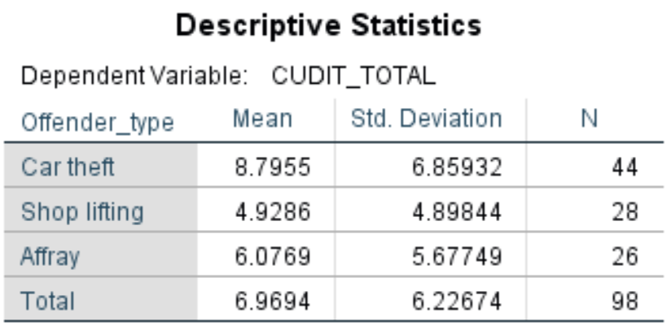

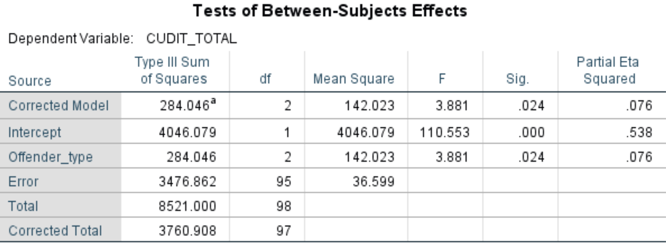

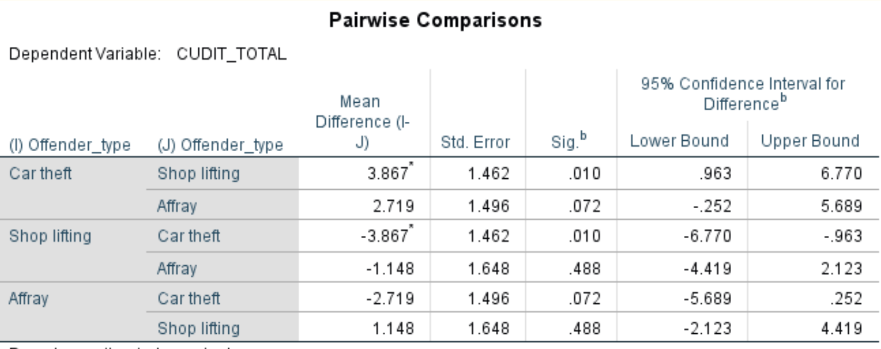

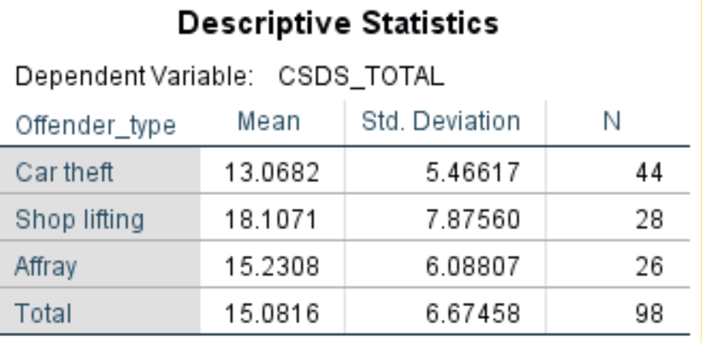
Offender type on CSDS

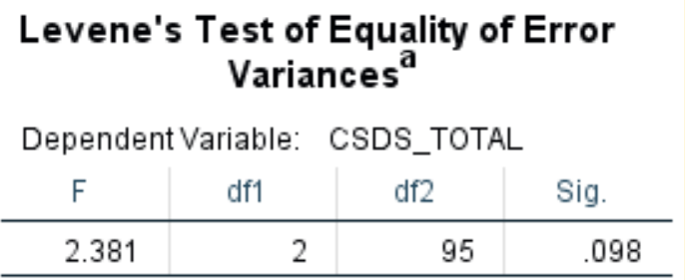

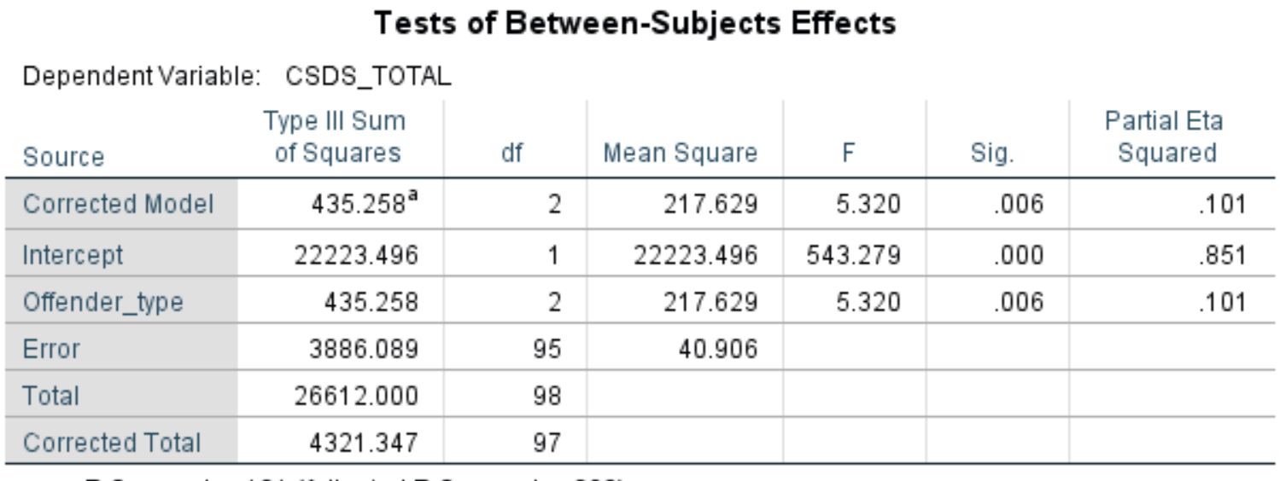

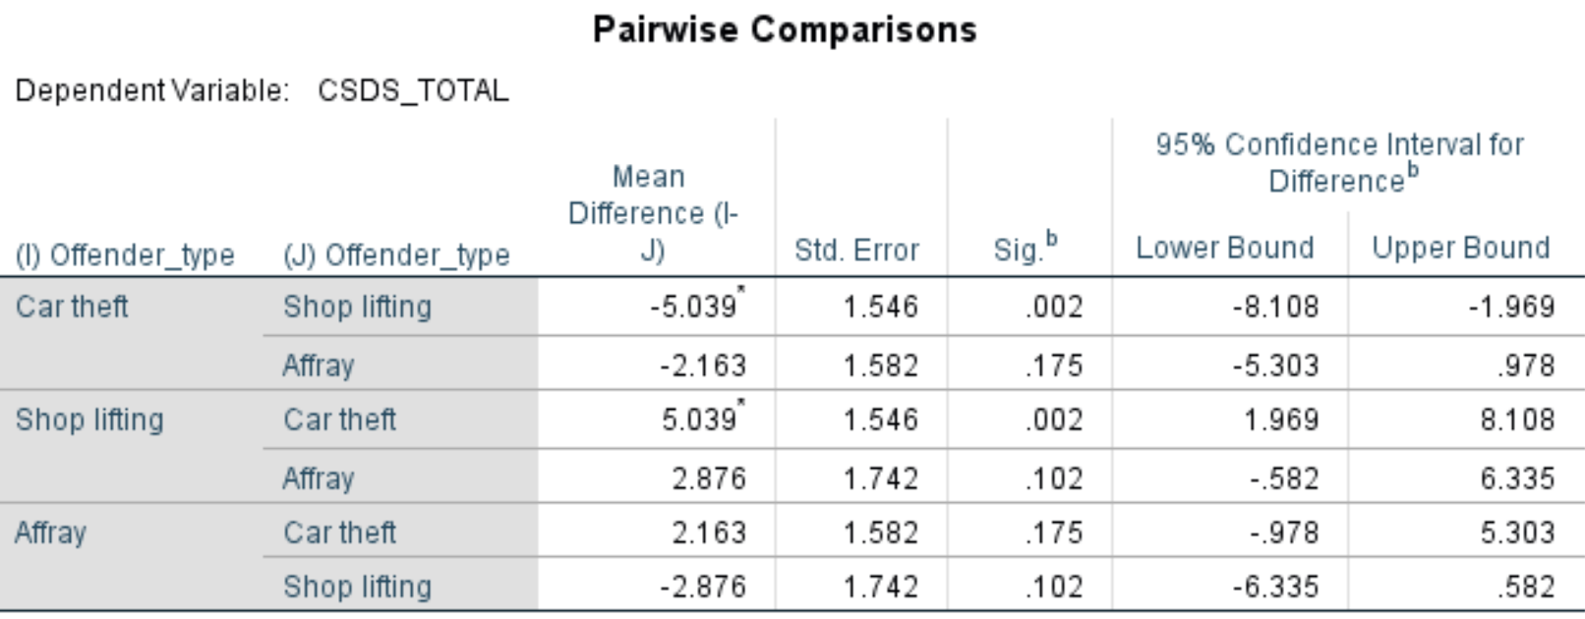

1. Using appropriate statistics describe the split half reliability of the two scales, state which scale is best. (3 marks)
2. Using appropriate statistics describe the alpha reliability of the two scales, state which scale is best. (3 marks)
3. Using appropriate statistics describe the test-retest reliability of the two scales, state which scale is best. (3 marks)

Using the scale with the best psychometric properties, answer the following questions regarding the analysis that explores the association between offender type and cannabis use.

4. Dose the analysis meet the assumption of homogeneity of variance? How do you know this?
(2 marks)

5. Write up the effect of offender type reporting post hoc tests if necessary
(7 marks)
6. Do you support the hypothesis? Explain your answer (2 marks)

