Multivariate ANOVA (MANOVA)

People in the UK are renowned for their high levels of binge drinking; indeed the UK (and Ireland) has the highest binge drinking rates in Europe. Why is this? One possible reason is the “drinking motives” that people have. Drinking motives represent motivational constructs that drive us to drink alcohol, for example some people drink as it facilitates social interaction, this would be a social motives. There are believed to be four major drinking motives.
1. Coping- drinking to cope with negative moods e.g. coping with anxiety and depression (internal, negative reinforcement)
2. Conformity- drinking so you do not feel left out of the group (external negative reinforcement)
3. Enhancement- because you enjoy the subjective effects/”buzz” that alcohol gives you (internal positive reinforcement)
4. Social- because it makes socialising more fun (external positive reinforcement)
A postgraduate student wishes to identify if there are any cross-cultural differences in drinking motives so creates an online questionnaire measuring drinking motives.
Participants also give information on where they were born, the researcher categorises people as
1. UK
2. Other EU
3. Rest of the world (other)
The student wishes to test if the IV- place of birth with 3 levels (UK/EU/other) has an effect on any of the four drinking motives (Coping/Conformity /Enhancement/Social). When investigating any significant effects the LSD test was used
The hypotheses are that (1) that UK drinkers will have stronger enhancement and social motives than the other groups. (2) Rest of the world drinkers will show higher conformity motives than the other groups. (3) EU drinkers will show higher coping motives than other groups
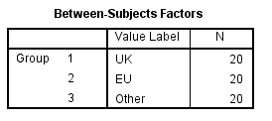

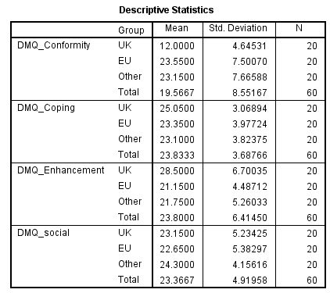

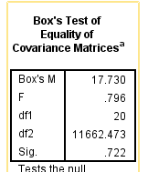

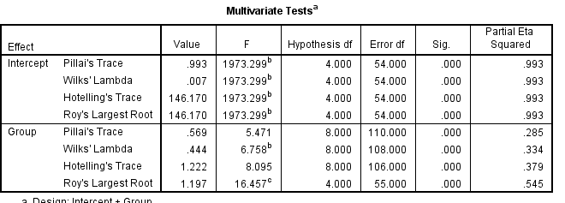

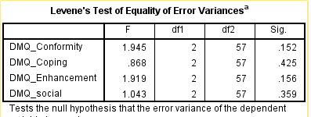

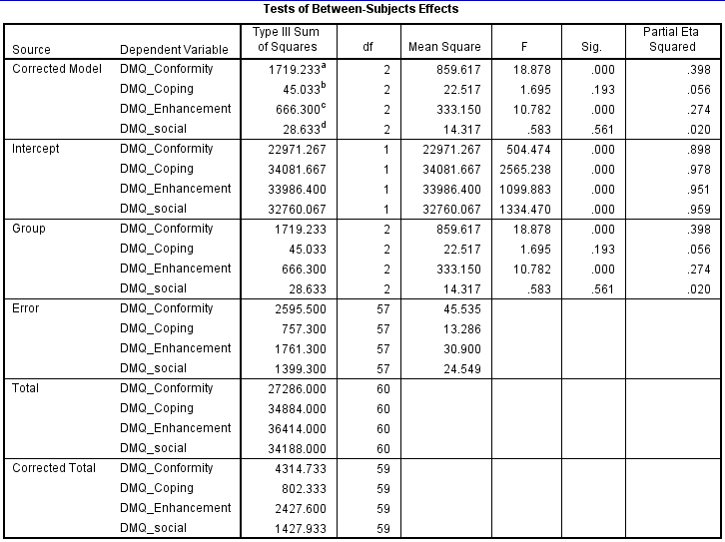

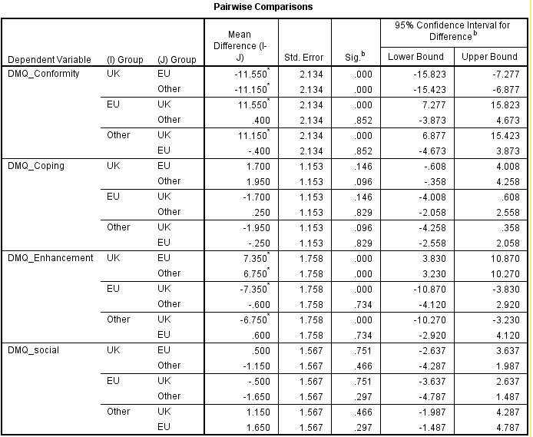

Write up:
3a. What does Box’s test measure and is this a problem for this data? (2 marks)

3b. Write up the multivariate test statistic in continuous prose using APA formatting. (2Marks)

3c. What is does Levene’s test measure and should we be concerned about any of the Levene’s tests? (2Marks)

3d. Write up the ANOVAs for the individual DVs in continuous prose using APA formatting, and report the post hoc tests where appropriate. (14 marks)

Other possible Q’s

3e. What could you do if your fail to find an acceptable Levene’s test? (2marks)

3f Do you support the hypotheses? Explain your answers? (6 marks)

