The Value of Organization in Math
Organization is a foundation for productivity as well as for solving math problems. In MAT110, applying organizational skills is two-fold. First, it is essential to being productive, for example, when you organize your workspace and manage your time, which allows you to be a successful student. Second, organizational skills are also essential when solving math problems since you must plan how to solve a problem, organize steps in a logical order, and work efficiently through those steps.
Each time you solve a math problem, you are strengthening your organizational skills, which are valued by employers and will help you lead a more productive life.

Each of the following problems will assess your ability to explain how you would apply organizational skills to math problems in real world situations.

Note: This assignment does not require research, but if you choose to use information from a source, be sure to cite it. To help make sure you are properly citing your sources, please review the Strayer Writing Standards. When you have answered all three questions, save the template with your completed responses as a Word document titled: Your Name_ MAT110_Week_4_Assignment and submit it in Blackboard in Week 4.

Question 1
Instructions
The two real-life scenarios below represent the importance of organization in mathematics. Specifically, the importance of being able to find a percentage of an amount without a calculator. In each scenario box below, add your explanations in the spaces provided.
Scenario 1
You are in a store and want to ensure you have enough cash for an unplanned purchase. You need to be able to calculate the sales tax for your purchase without a calculator.
Part A: Identify a situation that would fit into this scenario and explain how you would organize this calculation to solve it without a calculator. Assume a 5% sales tax rate. For full credit you will need the cost of the item, an explanation of how you would calculate the sales tax, and the total cost.
Example: I am shopping for school supplies at Target, and I have $130 extra. I see air pods on sale for $120. I want to determine if I have enough money to cover the total purchase price, including tax, before I get to the register. Here’s how I would organize the problem in my head (or on paper) to get an accurate calculation…
Type your response here:
Scenario 2
You are at a restaurant with three friends (party of 4) and need to estimate the amount of tip for your portion of the bill without using a calculator. Assume a 20% tip rate. For full credit, you will need the cost of your meal, an explanation of how you would calculate your 20% tip, and the total amount.
Part B: Explain how you would solve this problem by organizing a sample calculation.
Type your response here:

Part C: Refer back to your responses above for Parts A and B: Explain why organization was important in your thought process and calculation for an accurate solution. You should also reflect on how correct organization of a problem can help you in everyday life. Include real-world examples to support your response. Your answer should be a minimum of three sentences.
Type your response here:

Question 2:
Instructions:
The bar graph below represents the education levels of business owners in 2019. Review the details in the bar graph and interpret the data to answer parts A and B below.
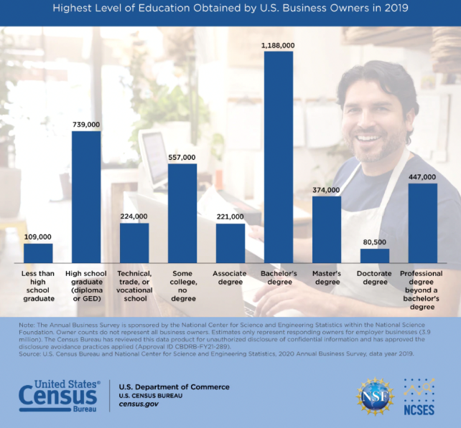
U.S. Census Bureau Annual Business Survey. 2020. Data year 2019. Graph.
Question 2 cont.
Part A: An aspiring business owner is planning their college course of study and would like to know whether they should pursue a doctoral degree before they open their own business. Explain what you would recommend to them using two specific examples from the bar graph to support your response. (Hint: You will need to review the number of business owners for each education level in the graph.)
Type your response here:
Part B: Explain why a bar graph is useful for organizing categorical data. Support your explanation with two different observations from the graph.
Type your response here:

Question 3:
Instructions:
Explain how you would organize your step-by-step calculations in evaluating the order of operations problem below. (Remember PEMDAS!) There should be five steps in this calculation. For full credit you must fill in the blanks below with your step-by-step explanation as well as computation for the correct answer. Add space as needed.
$$14 ÷2+3^{2} × (7-2)$$
Note: If there is no math expression above, please contact your instructor.
Type your response here:
Steps to organize the calculation:
- First, I would ___________________________________________________
- Next, I would ___________________________________________________
- Then, I would ___________________________________________________
- Then, I would ___________________________________________________
- Finally, I would __________________________________________________

When you have answered all three questions, save the template with your completed responses as a Word file titled: YourName_MAT110_Week_4_Assignment. Make note of the folder where your file is being saved to submit it in Blackboard in Week 4.

