Biology 110
What’s in Your Kitchen?
Guidelines and Questions
Select 30 items of processed food from your pantry/cupboard and refrigerator (for example, cereal, ketchup, soup, etc.; fresh fruits, vegetables, meat, dairy are not considered “processed” foods). Read the labels to determine if any of the corn-based food additives (also known as corn derivatives) listed in the Excel worksheet (“Kitchen Inventory”) are present. This worksheet is on Canvas > Research Assignment. For each food item, write its name and check off (with an X) the corn derivatives in the worksheet that you find in the list of ingredients. (Enter this directly in the Excel worksheet.) Also note whether the food itself is labeled as “natural” on the box or container.
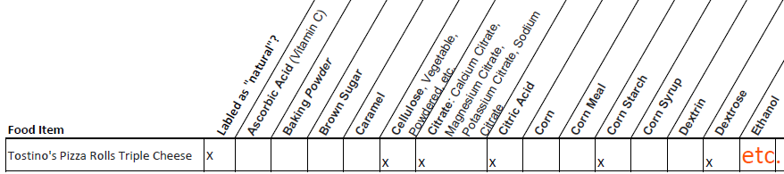
Here’s an example showing a
partial list of corn derivatives
in Tostino’s Pizza Rolls:

After you complete your survey, answer the following questions. Questions 4 and 5 require research and bibliographic citations (you should have between 6 to 8 sources for the entire assignment, not including Pollan). In-text citations are required for all ideas and information you derive from these sources. If you are uncertain what in-text citations are, check out this resource:

https://owl.excelsior.edu/citation-and-documentation/apa-style/apa-in-text-citations/

Use Google scholar to locate information (scholar.google.com). You can cite/use Pollan only once per question; beyond that, you must incorporate information from other sources. As noted above, you must paraphrase and cite all factual information. Put your references cited for questions 4 and 5 in #6 at the end. Do not use quotes (and don’t plagiarize either). Lastly, PROOREAD and EDIT carefully. I highly recommend that you install the free version of Grammarly (www.grammarly.com) on your computer.

Note: Use the same question number/format that you see below in your answers (e.g. your answer for 4c should be numbered 4c). You will lose points if you do not follow this convention!

1. Of the 30 items you chose, how many have corn-based food additives or corn derivatives?

2. Of the 30 items you chose, which, if any, had high fructose corn syrup (HFCS)?

3. What are your impressions of your “inventory”? You might include: what, if anything, surprised you the most? What did you learn from doing this inventory? What would you like to know more about? This response should be about 500 words. Put your word count for this response at the end of 3.

4. Regarding high fructose corn syrup (HFCS):

a. What is HFCS a blend of? (See page 89 in Pollan; this can be a single sentence.)

b. What is the economic significance of HFCS? In responding to this question, don’t just regurgitate Pollen’s statements. Think about what it means for something like HFCS (and corn) to be such an important and lucrative commodity. Should we be concerned about the influence of industry? Use Google Scholar to find additional information. This response should be about 250 words. Put your word count for this response at the end of 4b.
Continued on next page
c. Read (or re-read) Chapter 6 carefully, with an eye on the impact of the creation of HFCS. What effects has the “invention” of HFCS had on Americans? Use Google Scholar to find additional information. The response to this should be about 500 words, so you should treat this as a mini-essay. Think about this and organize your ideas and points. Put your word count for this response at the end of 4c.

5. Refer to page 98 in Omnivore’s Dilemma. What is the point Pollan makes about the label “natural”? How many of the foods in your inventory were “natural” and yet contained corn derivatives? Use Google Scholar to find additional information about “natural” foods being promoted “healthy” foods. This response should be about 250 words. Put your word count for this response at the end of 5.

6. References Cited: give the full bibliographic citation for each reference you cited in questions 4 and 5. As noted above, you should have between 6 and 8 references in total. You can use MLA or APA as long as you are consistent and correct). I highly recommend that you use a free bibliographic management program called Mendeley to organize your references and to create a References Cited section to copy and paste under #6 (www.mendeley.com). I have put a link to a 3 minute tutorial on using Mendeley on Canvas under Resources. It is incredibly easy to use and will save you time.

Submit this file (with your responses, of course) and your completed Excel worksheet or Google sheet with your inventory to Canvas > Assignments > What’s In Your Kitchen. (Canvas will allow you to upload multiple files under one assignment.)

