The International Management Research & Report assignment is the major project for this course. Students will select a country of interest and conduct research on two major topics: (1) Its business / economic environment and (2) cultural behaviors and anomalies specific to the Business environment of that country. The assignment will be submitted in a series of steps (“parts”) each week throughout the semester. Instructions for report formatting may be viewed on page 10 of the Course Syllabus. The Report will consist of eight (8) parts / submissions and instructions will be posted each week in D2L. The instructions are included along with the content specific to the completion of the assignment. In other words, instructions and resources are posted together.

It may be helpful for you to ‘pretend’ you have been reassigned to the country you selected for a 2 – 3-year project for your organization. Obviously, you will be living there AND expected to deliver productivity for your organization. You may select a business (or government assignment), if you find that helpful in completing this assignment.

FIRST STEP:

During the first week of the semester, select the country on which you will conduct your Research Project & Report assignment. Post your selection in the Discussion Forum provided for this step.

Part 1 (due WEEK 2) INSTRUCTIONS

Visit the U. S. Central Intelligence Agency’s (CIA) website to locate the World Fact Book: https://www.cia.gov/the-world-factbook/ . This resource is published annually by the CIA and is a reliable resource for successful Managers responsible for employees of other cultures or managing an international operation. Scroll down the website and look for “Explore Countries” section. From the dropdown menu box, click on the country you selected for the project:

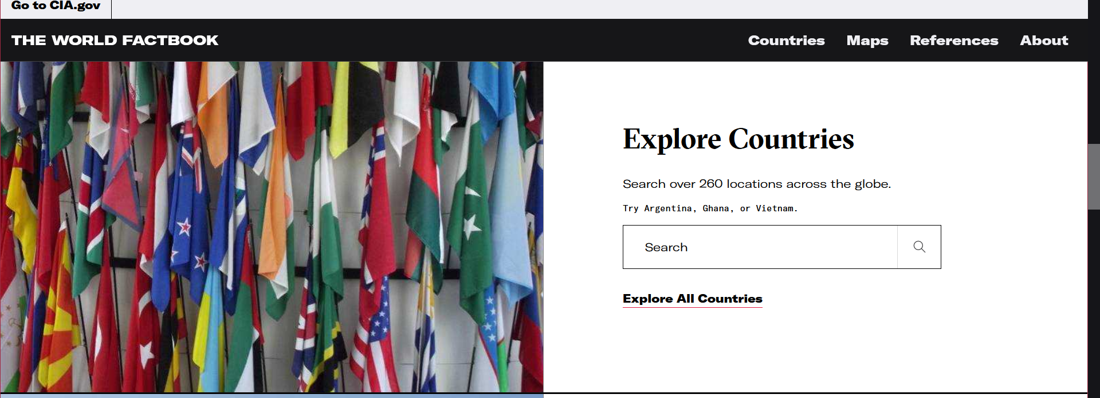

When your country page opens, you will find a gold mine of information, including photos of locations of interest. Look over the (1) brief history of your country. Next you will find (2) geographic information. Geography plays a major role in a country’s climate, culture, civilization, conflicts, economy, and wealth. Read over the geography and reflect on ways your country’s geography impacts cultural and economic characteristics. Next in the World Fact Book website is information about the country’s (3) “People & Society.” Very interesting information! Even includes the percentage of “children under the age of 5 years who are underweight.” You see how rich this resource is! Continue your country investigation to include (4) Environment, (5) Government, (6) Economy, (7) Energy, (8) Communications, (9) Transportation Systems, (10) Military & Security, and (11) Terrorism.

As you look over this information, focus on how these characteristics will affect (positively or negatively) the Business environment. Select six (6) of the above characteristics reviewed in the World Factbook and compose an essay on how you see the characteristic will impact your sojourn and business success. Your completed essay should be between 4 – 6 pages (double-spaced). Remember to maintain the focus on the affect the characteristic will have on your business. [For example, you see in “People & Society” that 12.05 million children between the ages of 0-14 years, and you work for Mattel Corporation….You have hit a target rich market!]

Submit your completed Part 1 assignment in the Assignment dropbox by the end of WEEK 2.

