https://www.pointlomahigh.com/apps/video/watch.jsp?v=53051
JE#6: Please refer to the Modes of Analysis section in your Bb Gallery Guide, your Methodologies document located in your Materials folder, and also in your textbook's Introduction chapter.
1.Which methodology would best describe the film's theme, and the overall unity of the film? And, why?
2. Personal Response: Would you invite a stranger into your bunker/fallout shelter? Why, or why not?

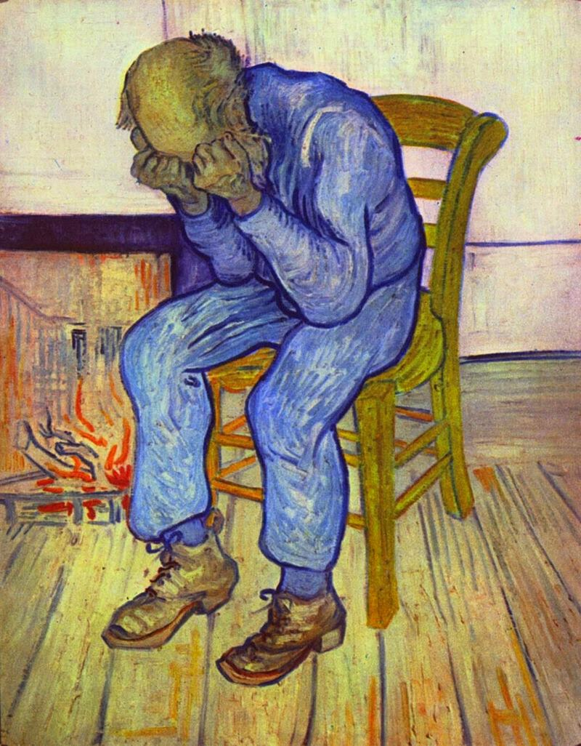
https://www.youtube.com/watch?v=KlBG2ojDbQ8
JE#5: Please use the Vincent van Gogh painting shown above to answer the questions:
1a. How does Vincent’s use of line and colour influence the autobiographical mood
of Sorrowing Old Man?
1b. Describe how, or not, the principles of Time and Motion are represented in this painting?
2. Personal Response: What does Spirituality mean to you?

https://www.youtube.com/watch?v=sRlvDKcDvsI
JE#4
1a. What was the theme of Mr Darger’s art?
1b. Was his use of collage effective in getting his story across?
2. Personal Response: how did you feel watching In the Realms of the Unreal? What do you think about Mr Darger as a person, and as an artist?

