Assignment details
Please use ASX website to choose the company!!!
You are to select a publicly listed dividend paying company from the country of your study location
(e.g. Australia for the Bentley campus) and conduct a detailed analysis on it.
Please go through the checklist on section 6 of this document before you commence your assignment.
Australia based students must NOT select Domino’s Pizza (DMP), banks, insurance companies, REITs and investment companies.
The purpose of this assignment is to use your acquired knowledge from this unit to investigate the
financial strength of a public listed company. Your research should cover the following 4 parts:
• Shareholder analysis (15%) – Who are the owners of the company and the implication to the
choice of methods used to calculate the cost of return.
• Risk-return analysis (15%) – Analyse the return received over the market for the apparent risks
identified in the company.
• Cost of capital (40%) – Calculate the cost of capital using various methods and analyse your
findings.
• Financial statement analysis (30%) – Determine the future of the company by analysing the
performance of the company.
In each of these parts, you are to report your findings using the format provided below. If the
information is not from the company’s annual report, you will have to provide details on
• where you sourced the information; and
• comment on how you have verified its reliability.
If the information is from the annual report, you do not need to reference, but you have to include the
page number of the annual report from which the information has been taken from, for example: (pg
XX).
The assignment must be written completely by you and your group members. You are not to purchase
or reproduce commercial stock reports

Before you start: Do not choose the company unless it satisfies the following, otherwise you will get a 30% penalty.
1 Dividend paying: Check if the company has been paying dividends for the last 2 years and has been listed for more than 5 years
2 Annual report: Check what is the latest available annual report. You must use the latest Page 4 of 16 report that has been released before 28th February 2022.
3 Reporting currency: Check that the company reports in local currency (AUD for ASX listed company). Look at the financial statements to verify.
4 Borrowings: Your company must have long term (non- current) borrowings for CAPEX. These are usually loans, bonds, notes or leases. Ignore accounts or trade payables, deferred tax or claim liabilities, provisions and employer entitlements and derivatives.
5 Earnings per share: Make sure that your company does not have a negative earnings per share. 6 Referencing: • Use referencing sparingly. More reference means less critical assessment. You are not awarded marks for putting forth opinions of others. • Footnote referencing is preferred. Chicago style is acceptable. • Referencing must be consistent. • Do not reference material from textbooks and lecture slides. • Do not include definitions or theory. • If the information is from the annual report, do not reference; instead include the page number of the annual report from which the information has been taken from. • Do not quote from the annual report, journal articles, textbook and lecture slide or provide formulas and definitions to equations; just show your workings. • Appendices without intext page number reference will not be looked at. • Do not reference from stockbroking or investment companies/website/articles; including but not limited to Simply Wall Street, Intelligent investor, Investsmart, Motley Fool, investing.com, Investopedia, etc

Part 1
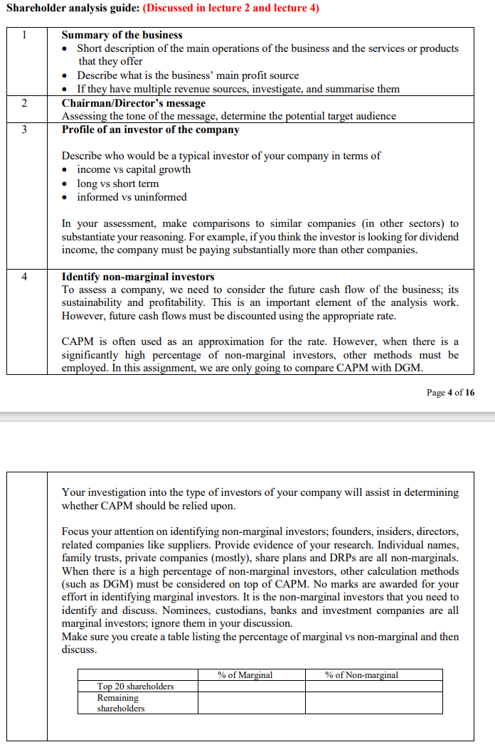

Part 2
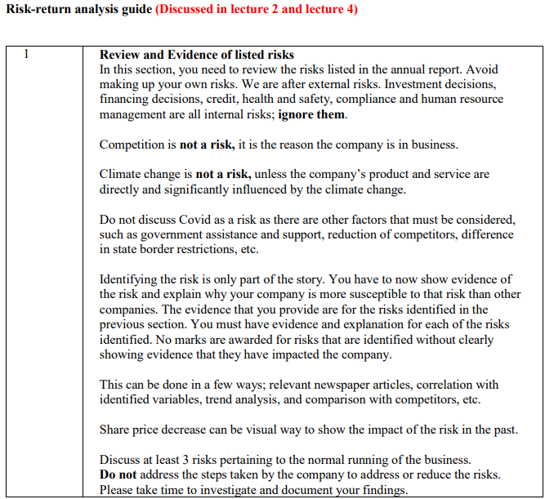
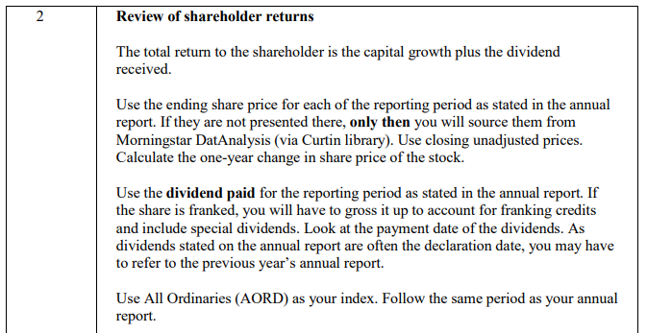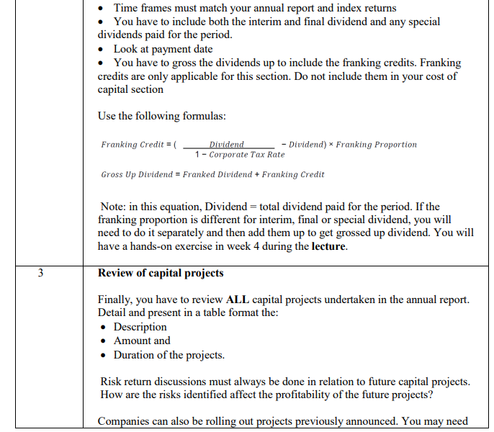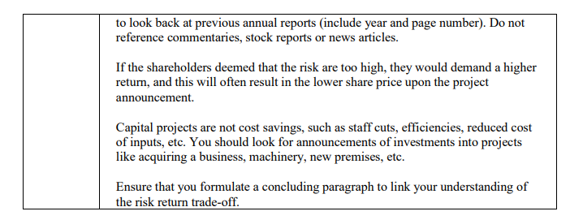

Part 3
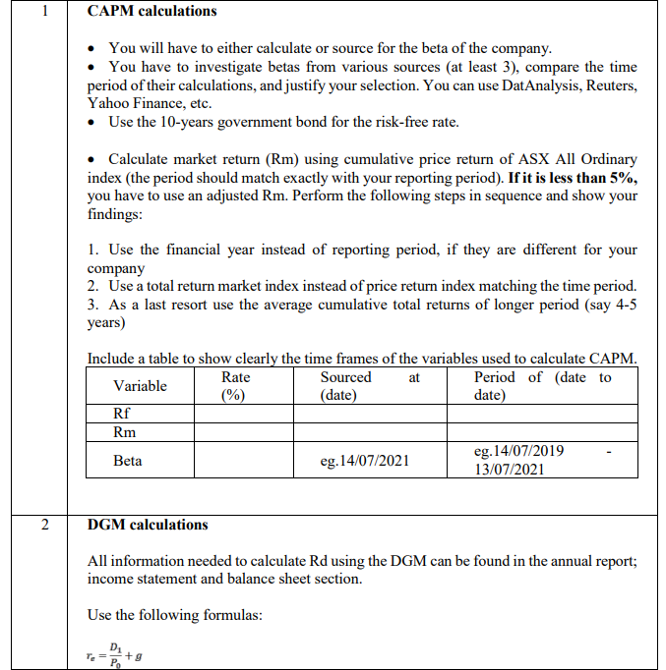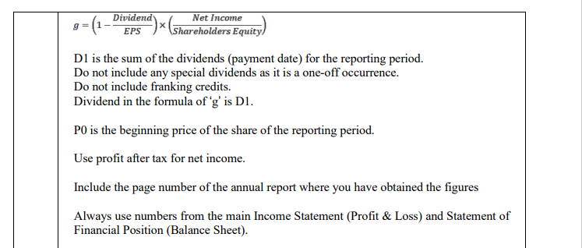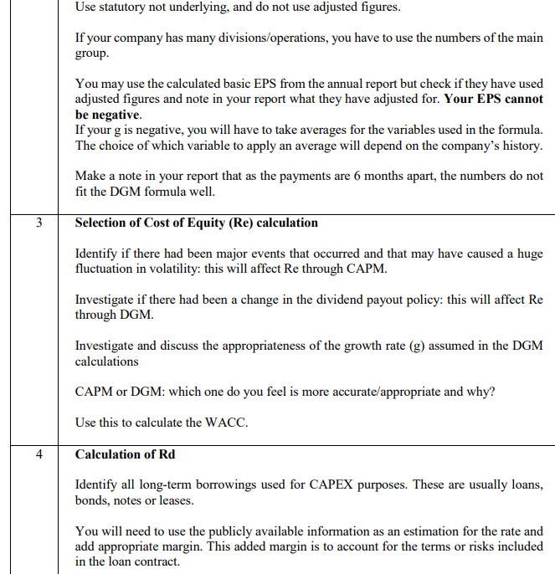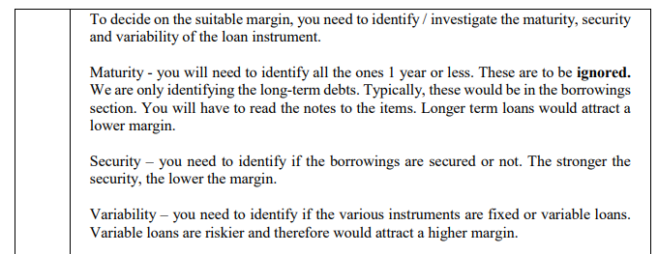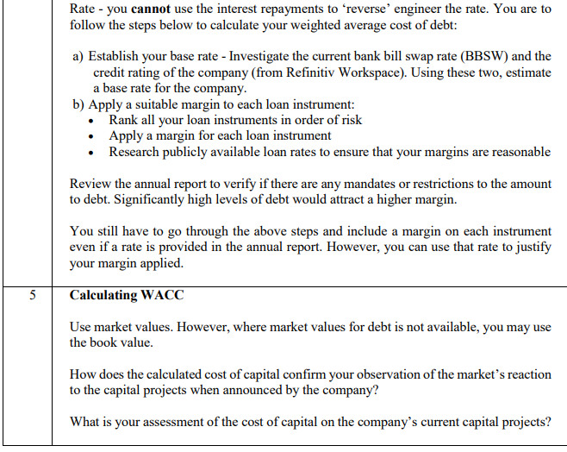

Part 4
