Calculating the Epicenter of an Earthquake Assignment

Purpose:
The purpose of this activity is for you, the student, to use seismic data to identify the latitude and longitude of the epicenter of an unknown earthquake in Part 1. In Part 2, you will demonstrate your understanding of the theory behind the calculation of an earthquake epicenter. Finally, in Part 3, you will describe the economic, cultural, environmental, and/or demographic impacts of a separate, real, specific seismic event.

Due Date:
This assignment is due by. When you are done, submit the completed Worksheet with your essay and a copy of the map to your professor via his college email with the following filename:
LASTNAME ERSC 101 CGA S22

Grading:
This assignment is worth 100 points.

Directions:

Part 0: Review before Starting the Assignment
- Review the Earthquake Lab in your lab manual and the section on seismic waves in your text (Chapter 5 of The Good Earth.)
- Participate in a classroom discussion or review this tutorial on the properties of maps.
- Participate in a classroom discussion about how to read the time travel curve or complete the online tutorial on reading the time travel curve.
- Review the concepts of latitude and longitude by watching this tutorial.

Part 1: Find the Epicenter of an Unknown Earthquake
Fill out and turn in the form below.
Name:
Student ID:
Section:
- Use the P wave and S wave arrival times in the Data Table below to find the lag time in seconds and the distance from the epicenter in kilometers for each station. (The time travel curve is included at the end of this document.)
- Print out a copy of the map found at the end of this document.
  - Use a drawing compass and the scale at the bottom of the map to draw arcs/circles around each of the three stations on the map. The three arcs you draw should come close to intersecting.
  - Clearly mark and label the earthquake epicenter on your map.
  - Make sure to hand in your map when you submit the rest of the assignment.
Data Table:
Station | P Wave  Arrival Time | S Wave  Arrival Time | Lag Time (s) | Distance (km)
Tokyo | 9:24:40 | 9:33:10
Mariana (second island from the N toward the S) | 9:24:20 | 9:32:20
Tahiti | 9:30:00 | 9:36:00

Part 2: Reflect on the Process
After finding the epicenter, answer the short answers questions below. Make sure to answer the questions in full sentences and cite your sources in MLA 8 style – see the Library Guide on MLA 8 for help.
- What was the latitude and longitude of the unknown earthquake?
- Describe in several complete sentences how this activity helped you to understand how the epicenter of an earthquake is determined.
- Could you have found the epicenter if you had data from a single station only? Explain.
- What was the minimum number of stations that you had to use to locate the epicenter? Explain.
- Why did the three circles not necessarily intersect perfectly? Consider how you found your data, the properties of maps, and other factors that may have been sources of error. Be specific.
- Why did you have to draw circles around each station in order to pinpoint the epicenter? Why couldn’t you just use the distance from each station to go directly to the epicenter in a straight line? Explain.

Part 3: Research a Separate, Real Seismic event. Make sure to include the works cited.

- Do some research and chose a real seismic event that has impacted people. The ERSC 101 Library Guide is a great place to start your research.
- Write a report about this specific seismic event
  - Make sure to include:
    - The name and date of the event
    - The magnitude of the event
    - The location of the event
    - The names of the tectonic plates that shifted to cause the event
    - The impacts of the event. This synopsis of the event's impact should include a minimum of 4 of the following areas of impact. (Each impact should be explained in its own separate paragraph)
      - its economic impact
      - its cultural impact
      - its sociological impact
      - its political impact
      - its demographic impact
      - its geological impact
  - Your report needs to:
    - Include an introduction, body paragraphs, and a conclusion
      - Use at least 3 academically appropriate sources (The Earth Science CCBC Library Research Guide is a good source for reliable information).
    - MLA style in-text citations and a full works cited page. The Library Guide on MLA 8 is a useful resource.
    - Be at least 500 words (this does not include the works cited page or headings)
  - Include your report at the end of this document.

Materials:
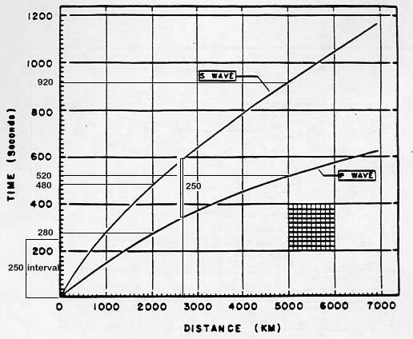
Figure 1: Time Travel Curve
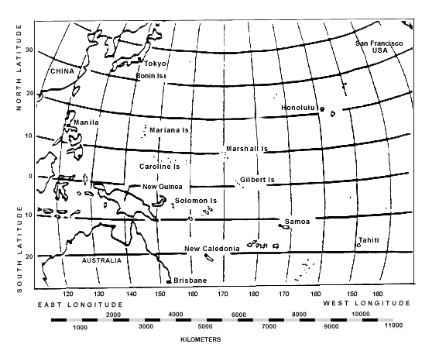
Figure 2: Map

