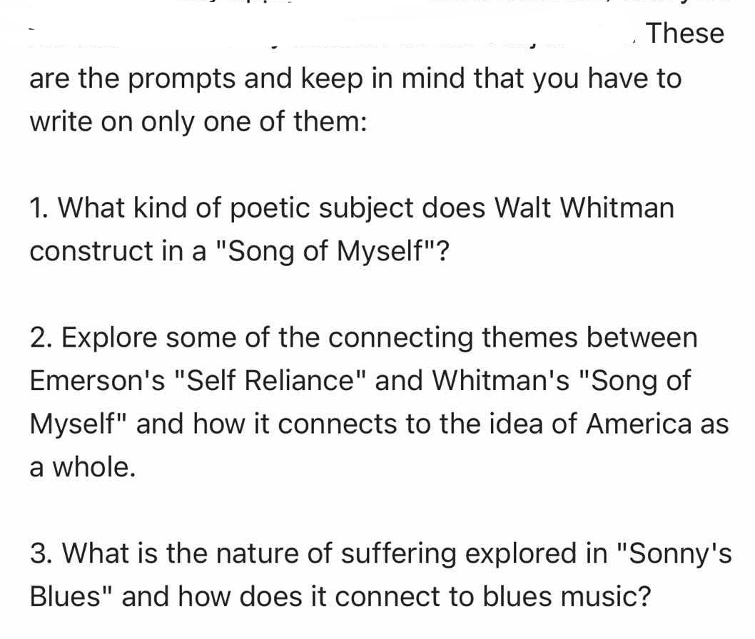
Essay 1 -(4 page)
essay assignments (4page double-spaced ) will ask you to conduct a close reading of at least one text in context, in which you analyze that text based on your own interpretation + thesis-driven argument. Lastly, while you are not required to cite secondary sources in your essays, doing so can bolster your essay’s argumentation, and is thus recommended.

